MiSACWIS Project

CF54 – Find a Person Screen Specification
Version 1.15

June 22, 2016

Prepared for:


120 N. Washington Square
SACWIS Project, 3rd Floor
Lansing, MI 48933

Prepared by:

Revision Log
Version | Date | A/D/C (Add, Delete, Change) | Author | Document Section # | Description
0.1 | 08/09/2011 |  | P. Rasher |  | Initial version
0.2 | 10/12/2011 | A, C, D | P. Rasher | 3.1.5 | Update business rules in DD Day 4 session. Remove obsolete preview screen S02.
0.3 | 10/13/2011 | A, C | P. Rasher | 3.1.2, 3.1.3, 3.1.8 | Update screen & field grids per BRT, standardize field grids, 3.1.8
0.4 | 10/14/2011 | C | P. Rasher | 3.1.3 | Specify person Address fields in results grid.
0.5 | 10/19/2011 |  | P. Rasher |  | Updated DD Day 9
0.6 | 10/20/2011 | C | P. Rasher | 3.1.4, 3.1.8 | Update Action Buttons, add PersonSort RefData
1.0 | 10/20/2011 |  | K. Stone |  | Day 10 Approved
1.1 | 12/22/2011 | C | P. Rasher | All | CC 2308
1.2 | 01/09/2012 |  | P. Rasher |  | Approved CC 2308
1.3 | 03/27/2012 |  | P. Rasher |  | CC 6603 View Bridges Relationships
1.4 | 04/09/2012 |  | P. Rasher |  | CC 6603 review and Approved
1.5 | 09/27/2012 | C | P. Rasher | 3.1.3 | CC#18888
1.6 | 10/16/2012 | C | P. Rasher | 3.1.5.2, 3, 4 | CC#20491 IIR calls
1.7 | 10/24/2012 | C | P. Rasher | 3.1.2, 3.1.3, 3.1.5 | CC#20824 race, 20738 last 4 ssn
1.8 | 01/24/2013 | C | P. Rasher | 3.1.5 | CC#25893 move BR from CM20g regarding searching on child’s pre-adoptive
1.9 | 02/18/2013 | C | M. Van Hoose | 3.1.5 | CC#27786 to add BR 24.
1.10 | 11/13/2013 | C | P. Rasher | 3.1.5#4 | CC#49385 correct 3.1.5 BR 4
1.11 | 06/23/2014 | A/C | Mike Stubbs | 3.1.5.25  3.2 | CC# DTMB00061425  Added Person Preview page
1.12 | 12/16/2014 | A, C | P. Rasher | 3.1.5#25, 26, 3.1.9 | CC#73445 Unless called directly from Search > Person Search, do not show adopted individuals in search results
1.13 | 04/28/2016 | A, C | P. Rasher | 3.1.4, 3.1.5#28, 3.1.7 | CC#110236 Provide Cancel button on Person Search screen for sub-function calls
1.14 | 05/25/2016 | C | P. Rasher | 3.1.5#26 | CC#101671 return pre-adoptive persons if called from certain use cases
1.15 | 06/22/2016 | C | M. Van Hoose | 3.1.5#29 | CC#110957 Unknown person search
Table of Contents
1 Introduction 6
1.1 Purpose 6
1.2 Scope 6
2 Use Case Details 7
2.1.1 Action Buttons/Hyperlinks 7
2.1.2 Business Rules 7
2.1.3 Security Requirements 7
2.1.4 Screen Navigation 7
2.1.5 Tab Order 8
2.1.6 Pre-Conditions 8
2.1.7 Ticklers 8
2.1.8 Notifications 8
2.1.9 Calendar 9
2.1.10 Reports 9
2.1.11 Notes and Assumptions 9
3 Screen Details 10
3.1 S01 – Person Search Screen 10
3.1.1 As Is – Screen Mock Up 10
3.1.2 To Be – Screen Mock Up 11
3.1.3 Screen Fields 12
3.1.4 Action Buttons 17
3.1.5 Business Rules 17
3.1.6 Screen Navigation 24
3.1.7 Pre-Conditions 24
3.1.8 Reference Values 24
3.1.9 Notes and Assumptions 24
3.2 S02 – Person Preview Screen 25
3.2.1 As Is – Screen Mock Up 25
3.2.2 To Be – Screen Mock Up 25
3.2.3 Screen Fields 26
3.2.4 Action Buttons 30
3.2.5 Business Rules 30
3.2.6 Security Requirements 30
3.2.7 Screen Navigation 30
3.2.8 Reference Values 30
3.2.9 Pre-Conditions 30
3.2.10 Notes and Assumptions 30

List of Figures
Figure 1 – Person Search –Screen Mock Up 10
Figure 2 – Person Search – Updated Screen Mock Up 11
Figure 3 – Person Preview Search – Existing Screen Mock Up 25
Figure 4 – Person Preview Search – Updated Screen Mock Up 25

- Introduction
  - Purpose
This screen specification describes the process for searching for a Person.
  - Scope
This function includes both a stand alone primary function that a user can access to find a person. It also includes how this use case can be accessed by other use cases as a sub function to that business process.

- Use Case Details

    - Action Buttons/Hyperlinks
Status (Keep/Add/Modify/Delete) | Label | Type | On Click Action/Navigation
N/A
    - Business Rules
No. | Status (Keep/Add/Modify/Delete) | Business Rule Description | Modified Business Rule Description | Execution Event (field tab out/save etc) | Error Msg Code  To be completed by Development Team
N/A
    - Security Requirements
No. | Status (Keep/Add/Modify/Delete) | Security Requirement
1 | Keep | Reference the individual screens for the security requirements
    - Screen Navigation
No. | Status (Keep/Add/Modify/Delete) | To Screen Navigation Path
1 | Keep | Reference the individual screens for the navigation path
    - Tab Order
No. | Status (Keep/Add/Modify/Delete) | Screen name
 | NA
    - Pre-Conditions
No. | Status (Keep/Add/Modify/Delete) | Pre-Condition
1 | Keep | Reference the individual screens for the pre-condition
    - Ticklers
Status (Keep/Add/Modify/Delete) | Tickler Name | Trigger Action | Tickler Generation Business Rule & Description | Tickler Removal Business Rule | Tickler Text
Status (Keep/Add/Modify/Delete) | Tickler Role
 | N/A
    - Notifications
This section should reflect any alerts/ticklers that are generated at the use case level.
Status (Keep/Add/Modify/Delete) | Notification Name | Trigger Action | Message Business Rule & Description | Message Text
Status (Keep/Add/Modify/Delete) | Notification Role | Trigger Action | Message Business Rule & Description | Message Text
 | N/A
    - Calendar
Status (Keep/Add/Modify/Delete) | Calendar Name | Trigger Action | Calendar Event Generation Business Rule & Description | Calendar Event Date and Time Business Rule | Calendar Event Text
Status (Keep/Add/Modify/Delete) | Calendar Role
 | N/A
    - Reports
N/A

    - Notes and Assumptions
N/A
- Screen Details
  - S01 – Person Search Screen
    - As Is – Screen Mock Up
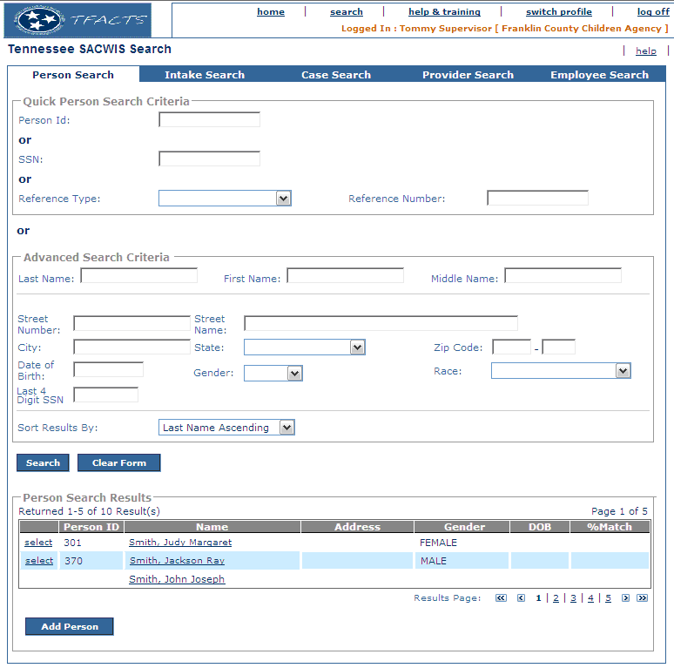
Figure 1 – Person Search –Screen Mock Up

    - To Be – Screen Mock Up
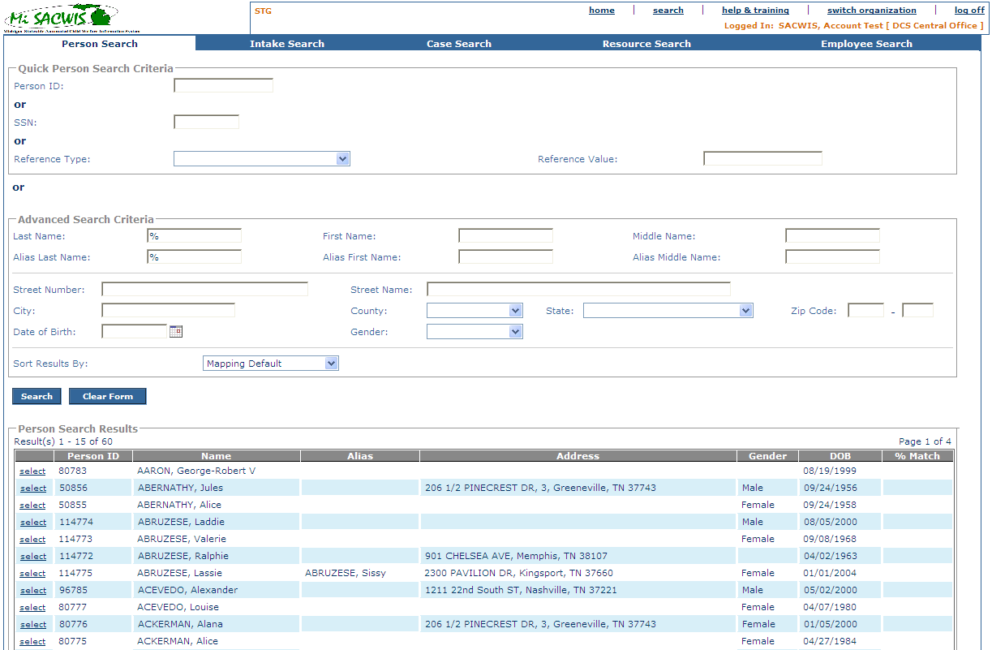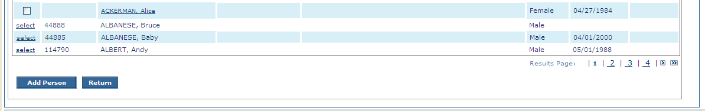
Figure 2 – Person Search – Updated Screen Mock Up
    - Screen Fields
Status (Unchanged/Add/Modify/Delete) | As Is Class.Attribute Name | To Be Class.Attribute Name | As Is Display Name | To Be Display Name | To Be Type | To Be Align | To Be Size | To Be Read Only | To Be Calculation | To Be Edit Mask | To Be UI Validation
Keep | Person.personId | Person.personId | Person ID | Person ID | Text Field | L | 10 | F | N/A | N/A | User selected  Not Required  No default  If Person ID is entered, all other entered search criteria is ignored.
Keep | Person.SSN | Person.SSN | SSN | SSN | Text Field | L | 11 | F | N/A | 999-99-9999 | User selected  Not Required  No default
Keep | PersonReference.personRefTypeCode | PersonReference.personRefTypeCode | Reference Type | Reference Type | Drop Down | L | 30 | F | Domain Code = PersonReference | N/A | Reference Type  Derived from Reference Code = ‘PersonReference’
Modify | PersonReference.personRefNbr | PersonReference.personRefNbr | Reference Number | Reference Value | Text Field | L | 20 | F | N/A | N/A | User selected  Conditionally Required if Reference Type selected  No default
Keep | Person.lastName | Person.lastName | Last Name | Last Name | Text Field | L | 35 | F | N/A | N/A | User entered  Not required
Keep | Person.firstName | Person.firstName | First Name | First Name | Text Field | L | 35 | F | N/A | N/A | User entered  Not required
Keep | Person.middleName | Person.middleName | Middle Name | Middle Name | Text Field | L | 25 | F | N/A | N/A | User Entered  Not Required
Add | N/A | AKA.AKALastName | N/A | Alias Last Name | Text Field | L | 35 | F | N/A | N/A | User entered  Not required
Add | N/A | AKA.AKAFirstName | N/A | Alias First Name | Text Field | L | 35 | F | N/A | N/A | User entered  Not required
Add | N/A | AKA.AKAMiddleName | N/A | Alias Middle Name | Text Field | L | 25 | F | N/A | N/A | User Entered  Not Required
Keep | Address.streetNbr | Address.streetNbr | Street Number | Street Number | Text Field | L | 20 | F | N/A | N/A | User selected  Not Required
Keep | Address.streetName | Address.streetName | Street Name | Street Name | Text Field | L | 100 | F | N/A | N/A | User selected  Not Required
Keep | Address.cityName | Address.cityName | City | City | Text Field | L | 60 | F | N/A | N/A | User selected  Not Required
Keep | Address.StateCode | Address.StateCode | State | State | Drop Down List | L | 30 | F | Domain Code = ‘State’ | N/A | User selected  Not Required
Keep | Address.ZIP5Code | Address.ZIP5Code | Zip | Zip | Text Field | L | 5 | F | N/A | 99999 | User selected  Not Required
Keep | Address.ZIP4Code | Address.ZIP4Code |  |  | Text Field | L | 4 | F | N/A | 9999 | User selected  Not Required
Keep | Person.birthDate | Person.birthDate | Date of Birth: | Date of Birth: | Date Field | L | 10 | F | N/A | 99/99/9999 | User Entered  Not Required  No future dates will be permitted. 1900 is the lowest year value permitted.
Keep | Person.genderCode | Person.genderCode | Gender | Gender | Drop Down List | L | 30 | F | Domain Code = ‘Gender’ | N/A | User selected  Not Required  Default to null
Delete | Race.raceCode | Race.raceCode | Race | Race | Drop Down List | L | 30 | F | Domain Code = ‘Race’ | N/A | User selected  Not Required  Default to null
Delete | Person.SSN | Person.SSN | Last 4 Digit SSN | Last 4 Digit SSN | Text Field | L | 4 | F | Search against just the last four digits of a person’s SSN | N/A | User selected  Not Required
Keep | N/A | N/A | Sort Results By | Sort Results By | Drop Down | L | 100 | F | Domain Code = PersonSort | N/A | User selected  Not required  Defaults to ‘% Match, descending’
Modify | N/A | N/A | Select | Select (hyperlink) or (checkbox) | Hyperlink or Check Box | L |  | N/A | N/A | N/A | System populated with checkbox when person result is returned from MCI, with Select hyperlink when person result is returned from MiSACWIS.
Keep | Person.personId | Person.personId | Person ID | Person ID | Display text | L | 22 | T | N/A | N/A | N/A
Keep | Person.lastName +  Person.SuffixCode + Person.FirstName + Person.MiddleName | Person.lastName +  Person.SuffixCode + Person.FirstName + Person.MiddleName | Name | Name | Display text or Hyperlink | L | 100 | T | Suffix code domain code = Suffix | Last name suffix, first name, middle initial 1 | Person name is hyperlink to IF902a_View_Bridges_Relationships when person results is returned from MCI.
Add | N/A | AKA.AKALastName +  AKA.AKASuffixCode + AKA.AKAFirstName + AKA.AKAMiddleName | N/A | Alias | Display text | L | 100 | T | Concatenated AKA name. Suffix code domain code = Suffix | N/A | Display if the match was made on the person’s AKA name.
Modify | Address.AddressLine1 + Address.AddressLine2 + Address.CityName +  Address.StateCode | Address. StreetNbr, PreDirectionalCode, StreetName, StreetSuffixCode, PostDirectionalCode, UnitNameCode, UnitNumber, CityName, StateCode, Zip5Code, Zip4Code, County_code | Address | Address | Display text | L | 100 | T | Domain codes: Direction, County, UnitName, State | N/A | Standard 1 line concatenated address.
Keep | Person.genderCode | Person.genderCode | Gender | Gender | Display text | L | 30 | T | Domain code = Gender | N/A | N/A
Keep | Person.birthDate | Person.birthDate | DOB | DOB | Display text | L | 10 | T | N/A | MM/DD/YYYY | N/A
Keep | N/A | N/A | N/A | % Match | Display text | C | 4 | T | N/A | N/A | N/A
Add | N/A | Address.CountyCode | N/A | County | Dropdown list | C | 100 | F | Domain code = County | N/A | User selectable  Not required

    - Action Buttons
Status (Keep/Add/Modify/Delete) | Label | Type | On Click Action/Navigation
Keep | Search | Button | Conducts the search based on the search criteria.
Keep | Clear Form | Button | Clears all values back to default values
Keep | Select | Hyperlink | Only available when used for primary search functions  Launches PM01i – Person Overview Use Case.
Keep | Add Person | Button | Only available when used for sub-function searches.  On data retrieval search page only; Takes the worker to create a person on the Person Profile Page – PM01. Also see Checkbox below regarding Add Person in conjunction with a selected (checked Checkbox) person result.
Modify | Select | Button | Only available when used for sub-function searches.  Returns the selected name to the calling use case
Keep | Return | Button | Only available when used for sub-function searches.  Returns to the calling page
Add | N/A | Checkbox | Only available when used for sub-function searches.  When Add Person button clicked, call MCI Web Service Person Detail Inquiry for the checked person to obtain Person data which is pre-filled into Add Person screens. Reference TF03 Interface Agreement Document for details.
Add | N/A | Hyperlink | Person name is hyperlink when the person result is from MCI. Clicking the hyperlink invokes IF902a 2.5.15 (request) and 2.5.16 (results) to pop-up the View Bridges Relationships screen IF902a_view_bridges_relationships.
Add | Cancel | Button | Only available when used for sub-function searches.  Return to the calling page.
    - Business Rules
No. | Status (Keep/ Add/ Modify/ Delete) | Business Rule Description | Modified Business Rule Description | Execution Event (field tab out/save etc) | Err. Msg Code
1 | Modify | One of the following elements is necessary on all searches: last name, first name, middle name, person ID, SSN, reference type and number, or address information ( combination of both the Street Name and Number, City, State and Zip) | One of the following elements is necessary on all searches: last name, first name, middle name, person ID, SSN, reference type and value, or address information ( combination of both the Street Name and Number, City, State and Zip) | Search Button
2 | Modify | When the worker enters a value in the person ID field, all other fields are ignored and any information previously entered is removed. The system should make no call to IIR if this field is entered. | When the worker enters a value in the person ID field, all other fields are ignored and any information previously entered is removed. The system should make no call to IIR if this field is entered. | Search Button
3 | Modify | When the worker enters a value in the SSN field, all other fields are ignored and any information previously entered is removed unless the person ID is entered, in which case the SSN is ignored. The system should make no call to IIR if this field is entered. | When the worker enters a value in the SSN field, all other fields are ignored and any information previously entered is removed unless the person ID is entered, in which case the SSN is ignored. The system should make no call to IIR if this field is entered. | Search Button
4 | Modify | When the worker selects a reference type value, only the reference value is enabled. In combination, these two values are used together. All other fields are ignored and any information previously entered is removed unless the person ID or Social Security Number is entered. The system should make no call to IIR if this field is entered. | When the worker selects a reference type value, only the reference value is enabled. In combination, these two values are used together. All other fields are ignored and any information previously entered is removed unless the person ID or Social Security Number is entered. The system should make no call to IIR if this field is entered. If the Reference Type = Recipient ID and a Reference Value is provided, the system will call the Bridges web service Individual Details Inquiry Request as per the IF902a IA. | Search Button
5 | Modify | When the worker selects a value in either the gender or race field alone, the worker will receive an error message. | When the worker selects a value in the gender field alone, the worker will receive an error message. | Search Button
6 | Delete | The system should search the primary race of the person profile along with any other secondary race(s) identified in the person profile. |  | Search Button
8 | Delete | When ‘unknown’ is typed in either the first name or last name fields, the search will be terminated and the user will be presented with an error message. |  | Search Button  Error Code 1276
9 | Modify | When the user types in any combination of the name fields in the search criteria, the system should search against the person tables, the AKA name tables, and the SSMS tables. | When the user types in any combination of the name fields in the search criteria, the system should search against the person tables, the AKA name tables, and the SSMS tables. | Search Button  (IIR Configuration Business Rule)
10 | Modify | Any search results from the SSMS database (any records without a person ID) should have a checkbox instead of not have the ‘select’ hyperlink displayed next to it and the only field populated will be the Name field | Any search results from the SSMS MCI database (any records without a person ID) should have a checkbox instead of not have the ‘select’ hyperlink displayed next to it and the only field populated will be the Name field | Search Button
11 | Keep | When a user enters any combination of the first name or the middle name field, the system should search all first name and middle name fields on the person record for either name.  Example 1: If the user searches for Christopher (first name) Allen (last name) the system will make a match on any of the following names in the following order of confidence:  Christopher Allen  Christopher William Allen  John Christopher Allen  Example 2: If the user searches for Christopher (first name) John (middle name) Allen (last name) the system will make a match on any of the following names in the following order of confidence:  Christopher John Allen  Christopher Allen  John Allen  Christopher William Allen  John Christopher Allen |  | Search Button  (IIR Configuration Business Rule)
12 | Modify | When making a search against the IIR system, the following is the order of confidence ranked from highest confidence to lowest confidence:  - Any combination of the name fields  - Any combination of the address fields  - The DOB  - The Gender, Race, and Last 4 Digit SSN fields | When making a search against the IIR system, the following is the order of confidence ranked from highest confidence to lowest confidence:  - Any combination of the name fields  - Any combination of the address fields  - The DOB  - The Gender | Search Button  (IIR Configuration Business Rule)
13 | Keep | If the user enters data in any of the address fields, the ‘State’ field must not be null. |  | Search Button  Error Code 1277
14 | Delete | If a user calls this use case from the ‘Add Member’ Button on the S03 – Resource Summary – Members Screen for use case RM04, the system should automatically mark person(s) selected by the user for inclusion on RM04 with an indictor that SSA Validation must be done. |  | Select Button
15 | Delete | If a user calls this use case from the ‘Add Member’ Button on the S02 Members Tab Screen for use case CM03, the system should automatically mark person(s) selected by the user for inclusion on CM03 with an indictor that SSA Validation must be done. |  | Select Button
16 | Delete | If a user calls this use case from the ‘Add Person’ Button on the S01 – Investigation Persons Screen for use case IV21, the system should automatically mark person(s) selected by the user for inclusion on IV21 with an indictor that SSA Validation must be done. |  | Select Button
17 | Delete | If a SSMS record is returned in the search results, the select hyperlink and checkbox (if applicable) will not appear next to the SSMS Record returned. |  | Search Button
18 | Delete | If the user has the Restricted Report Viewer security that allows access to the SSMS Record View screen, the search result ‘Name’ column will appear as a hyperlink that launches this screen in both Primary and Secondary searches. Otherwise, it will not appear as a hyperlink for users that do not have this security. |  | Search Button
19 | Add | If Person ID is not null, the other search criteria fields on the screen are disabled. |  | Tab out of Person ID field
20 | Add | If SSN is not null, the other search criteria fields on the screen are disabled, except for Person ID. |  | Tab out of SSN field
21 | Add | If first name, middle name and/or last name are provided, also search against the person’s AKA names. |  | Search Button
22 | Add | If a result is returned due to matching on an AKA name, display the matching alias name in the Alias column. |  | Search Button
23 | Add | Searching on a child’s pre-adoption name will NOT retrieve any person level information (Person Overview) unless the user is the Closed Adoption Case Reviewer. |  | Search Button
24 | Add | MiSACWIS will alert the user if the number of matches found is greater than 50. If more than 50 records would be retuned, notify the user with a error message stating “Your search will return more than 50 records. Please add additional information in the search criteria to return less records.” |  | Search Button
25 | Add | If the person exists as a MiSACWIS Person record, the search result ‘Name’ column will appear as a hyperlink that launches the Person Preview screen. |  | Search Button
26 | Modify | When CF54 is called from functions other than Search > Person Search, search results will not include any pre-adoptive individuals (AdptHistory.oldPersonId or OrigPersonId whose adoption is finalized (AdptHistory.AdptFinalizedDate is not null)). | When CF54 is called from functions other than Search > Person Search, search results will not include any pre-adoptive individuals (AdptHistory.oldPersonId or OrigPersonId whose adoption is finalized (AdptHistory.AdptFinalizedDate is not null)) unless:  - Called from FM12g or  - Called from FM01 and the user has Closed Adoption Worker user group or  - Called from FM03 and the user has Closed Adoption Worker user group  then pre-adoptive persons will be returned in the search results. | Search button
27 | Add | When CF54 is called for the generic Search > Person Search, if a Person in the results is a pre-adoptive individual whose adoption has been finalized, the confidential indicator “[C]” will display next to the Person ID. |  | Search button
28 | Add | The Cancel button, displayed for sub-function calls, is hidden when the Person Search Results grid is displayed. |  | Page load of search results
29 | Add | If First Name, Middle Name or Last Name contain the word ‘Unknown’, do not return any results. |  | Search button
    - Screen Navigation
No. | Status (Keep/Add/Modify/Delete) | To Screen Navigation Path
1 | Keep | This can be accessed as a sub-function called from another Use Case.
2 | Keep | This can be accessed from the Search Hyperlink off the Home screen and clicking on the Person tab.
    - Pre-Conditions
No. | Status (Keep/Add/Modify/Delete) | Pre-Condition
1 | Keep | When called from another use case as a sub-function the following buttons will appear: Search, Clear Form and Cancel; when the search results grid is displayed the Cancel button is hidden, the ‘Add Person’ and ‘Return’ buttons appear and, depending on the persons returned by the search, the checkbox and select hyperlink are displayed.
    - Reference Values
Please reference the XLS_REF_DATA spreadsheet located in the Michigan SACWIS > Project Library > Detail System Design Work In Progress > Team 0 Infrastructure > Database > Seed Data folder

    - Notes and Assumptions
The screen shot listed below represents a scenario represented in BR3.1.5.25.
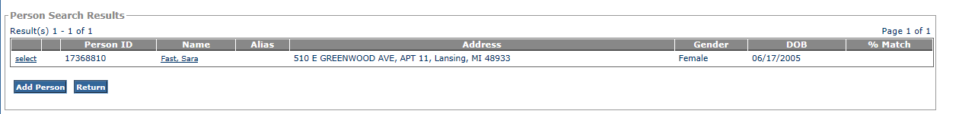

When called from functions other than the Search > Person Search, the results screen will display the note “Pre-adoptive persons whose adoption has been finalized will not be displayed in search results." between Result(s) n - n of n and Page n of n.

  - S02 – Person Preview Screen
    - As Is – Screen Mock Up
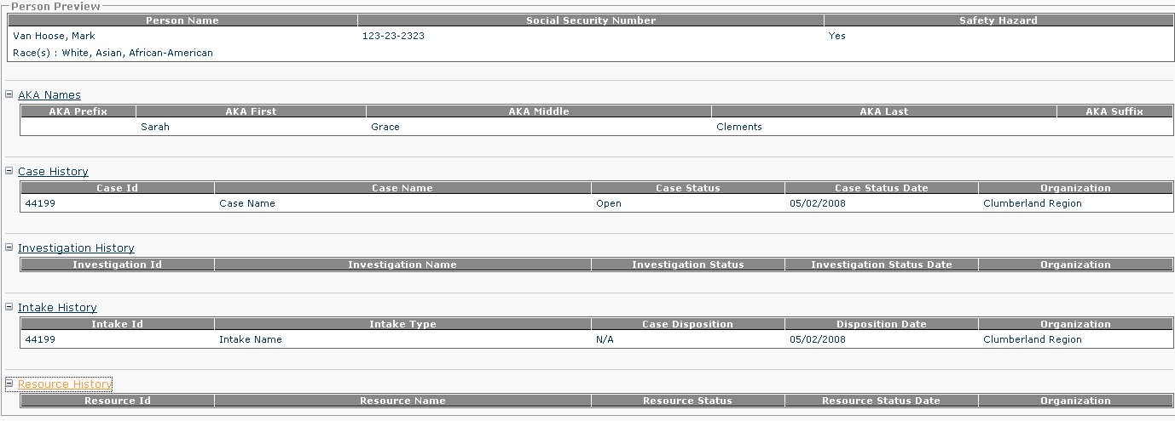
Figure 3 – Person Preview Search – Existing Screen Mock Up
    - To Be – Screen Mock Up
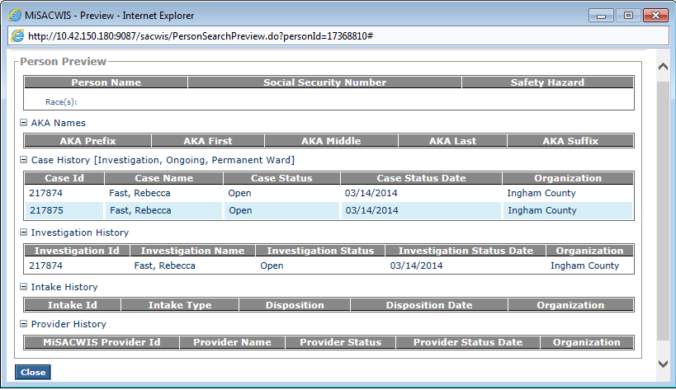
Figure 4 – Person Preview Search – Updated Screen Mock Up

    - Screen Fields
Status (Unchanged/Add/Modify/Delete) | As Is  Class.Attribute Name | To Be  Class.Attribute Name | As Is  Display Name | To Be  Display Name | To Be  Type | To Be  Align | To Be Size | To Be  Read  Only | To Be  Calculation | To Be  Edit Mask | To Be  UI Validation
Unchanged | Person.lastName + person.firstName + Person.middleName | Person.lastName + person.firstName + Person.middleName | Person Name | Person Name | Text Field | L | N/A | T |  | Last Name, First Name, Middle Name 1 | System Derived
Unchanged | Person.SSN | Person.SSN | Social Security Number | Social Security Number | Text Field | L | N/A | T |  |  | System Derived
Unchanged | Person.safetyHazardNarrative | Person.safetyHazardNarrative | Safety Hazard | Safety Hazard | Text Field | L | N/A | T |  |  | System Derived
Unchanged | Race.raceCode | Race.raceCode | Race(s) | Race(s) | Text Field | L | N/A | T |  |  | System Derived  All Races for the person concatenated
Unchanged | N/A | N/A | AKA Names | AKA Names | Expando | N/A | N/A | F |  |  | Opens AKA Names grid.
Unchanged | AKA.prefixCode | AKA.prefixCode | AKA Prefix | AKA Prefix | Text Field | L | N/A | T |  |  | System Derived
Unchanged | AKA.akaFirstName | AKA.akaFirstName | AKA First | AKA First | Text Field | L | N/A | T |  |  | System Derived
Unchanged | AKA.akaMiddleName | AKA.akaMiddleName | AKA Middle | AKA Middle | Text Field | L | N/A | T |  |  | System Derived
Unchanged | AKA.akaLastName | AKA.akaLastName | AKA Last | AKA Last | Text Field | L | N/A | T |  |  | System Derived
Unchanged | AKA.suffixCode | AKA.suffixCode | AKA Suffix | AKA Suffix | Text Field | L | N/A | T |  |  | System Derived
Unchanged | N/A | N/A | Case History | Case History | Expando | N/A | N/A | F |  |  | Opens the Case History Grid.
Unchanged | CaseBase.caseId | CaseBase.caseId | Case Id | Case Id | Text Field | L | N/A | T |  |  | System Derived
Unchanged | CaseBase.LastName + CaseBase.FirstName +  CaseBase.MiddleName | CaseBase.LastName + CaseBase.FirstName +  CaseBase.MiddleName | Case Name | Case Name | Text Field | L | N/A | T |  |  | System Derived
Unchanged | CaseStatus.caseStatusCode | CaseStatus.caseStatusCode | Case Status | Case Status | Text Field | L | N/A | T |  |  | System Derived
Unchanged | CaseStatus.beginEffDate | CaseStatus.beginEffDate | Case Status Date | Case Status Date | Text Field | L | N/A | T |  |  | System Derived
Modify | Agency.agencyName | Agency.agencyName | Agency | Organization | Text Field | L | N/A | T |  |  | System Derived
Add | N/A | N/A | N/A | Investigation History | Expando | N/A | N/A | F |  |  | Opens the Investigation History Grid.
Add | CaseBase.caseId | CaseBase.caseId | N/A | Investigation Id | Text Field | L | N/A | T |  |  | System Derived
Add | CaseBase.LastName + CaseBase.FirstName +  CaseBase.MiddleName | CaseBase.LastName + CaseBase.FirstName +  CaseBase.MiddleName | N/A | Investigation Name | Text Field | L | N/A | T |  |  | System Derived
Add | CaseStatus.caseStatusCode | CaseStatus.caseStatusCode | N/A | Investigation Status | Text Field | L | N/A | T |  |  | System Derived
Add | CaseStatus.beginEffDate | CaseStatus.beginEffDate | N/A | Investigation Status Date | Text Field | L | N/A | T |  |  | System Derived
Add | Agency.agencyName | Agency.agencyName | N/A | Organization | Text Field | L | N/A | T |  |  | System Derived
Unchanged | N/A | N/A | Intake History | Intake History | Expando | N/A | N/A | F |  |  | Opens the Case History Grid
Unchanged | Intake.intakeId | Intake.intakeId | Intake ID | Intake ID | Text Field | L | N/A | T |  |  | System Derived
Unchanged | IntakeType.intakeTypeCode | IntakeType.intakeTypeCode | Intake Type | Intake Type | Text Field | L | N/A | T |  |  | System Derived
Unchanged | IntakeDispositionRationale.DispoRationaleCode | IntakeDispositionRationale.DispoRationaleCode | Case Disposition | Case Disposition | Text Field | L | N/A | T |  |  | System Derived
Unchanged | IntakeDispositionRationale.createdDate | IntakeDispositionRationale.createdDate | Disposition Date | Disposition Date | Text Field | L | N/A | T |  |  | System Derived
Unchanged | Agency.agencyName | Agency.agencyName | Organization | Organization | Text Field | L | N/A | T |  |  | System Derived
Modify | N/A | N/A | Resource History | Provider History | Expando | N/A | N/A | F |  |  | Opens the Resource History Grid
Modify | Provider.providerId | Provider.providerId | Resource Id | Provider ID | Text Field | L | N/A | T |  |  | System Derived
Modify | ProviderName.NameText | ProviderName.NameText | Resource Name | Provider Name | Text Field | L | N/A | T |  |  | System Derived
Modify | ProviderName.effectiveDate | ProviderName.effectiveDate | Resource Status | Provider Status | Text Field | L | N/A | T |  |  | System Derived
Modify | ProviderName.effectiveDate | ProviderName.effectiveDate | Resource Status Date | Provider Status Date | Text Field | L | N/A | T |  |  | System Derived
Unchanged | Agency.agencyName | Agency.agencyName | Organization | Organization | Text Field | L | N/A | T |  |  | System Derived

    - Action Buttons
Status (Keep/Add/Modify/Delete) | Label | Type | On Click Action/Navigation
Keep | Close | Button | Closes the Person Preview Screen.
    - Business Rules
No. | Status (Keep/Add/Modify/Delete) | Business Rule Description | Execution Event (field tab out/save etc)
1 | N/A | N/A | N/A
    - Security Requirements
No. | Status (Keep/Add/Modify/Delete) | Security Requirement
1 | Keep | This screen can be accessed by any worker with read access to Person Search.
    - Screen Navigation
No. | Status (Keep/Add/Modify/Delete) | To Screen Navigation Path
1 | Keep | This screen is accessed by selecting the hyperlinked name on the Person Search screen.
    - Reference Values
Please reference the XLS_REF_DATA spreadsheet located in the Michigan SACWIS > Project Library > Detail System Design Work In Progress > Team 0 Infrastructure > Database > Seed Data folder
    - Pre-Conditions
No. | Status (Keep/Add/Modify/Delete) | Pre-Condition
1 | Keep | This screen should be launched in a separate window as a pop-up page.
    - Notes and Assumptions
The screen shot listed below represents how the Person Preview screen will appear as a pop-up screen in a separate window.
